Dear customer:  Thank you for purchasing EbangMiner!  The company guide provides a brief description of your mining machine and basic setup information. The detailed operational information, Please refer to http://miner.ebang.com.cn.  Precautions for miner use  - Please check the miner carefully before plugging in. If any of the hash boards are loose, or fall off during transit, please contact customer service.  - All 6PIN of hash boards need to connect with PSU, every hash board have three 6PIN. Please check and confirm that the connection is correct. One PSU can provide power for all hash boards, please don’t use two PSUs or more. Using multiple PSUs may cause irreparable damage to the miner.  - Please connect the PSU with controller first, then hash boards.(Because the fan is driven by the control board.) Please confirm all PINs and all cables are connected correctly before plugging in. | - Please leave a gap between the machine and the power supply.  - Ebang Miner's working environment temperature is 0~30°C, humidity requirement is 5%RH~95%RH, please avoid condensation at colder temperature.  - The product is not dustproof, please clean it regularly to avoid affecting performance.  - Specifications:  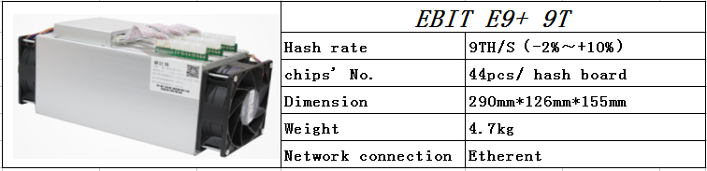  After-sales call: 0571-88179074  E-mail: ebit@ebang.com.cn  E9+miner User's Guide V1.0  Zhejiang Ebang Communication Co., Ltd

